The Beast of Rev 13: Representing the Holy Roman Empire

Three Horns: Three Barbarian Kingdoms
v. 1-2
1. Vandals 429-533 AD
2. Heruli 476-493 AD
3. Ostrogoths 493-554 AD
Seven Horns: Seven Revivals
v. 1-2
4. Imperial Restoration 554. This is the healing of the deadly wound. It revitalized the empire.
5. Frankish Kingdom 774
6. Holy Roman Empire Otto the Great (German Head) 962
7. Hapsburg Dynasty (Austrian
Head) 1530
8. Napoleon 1804
9. Italy (Mussolini and
Garabaldi) 1870-1945
10. US of Europe

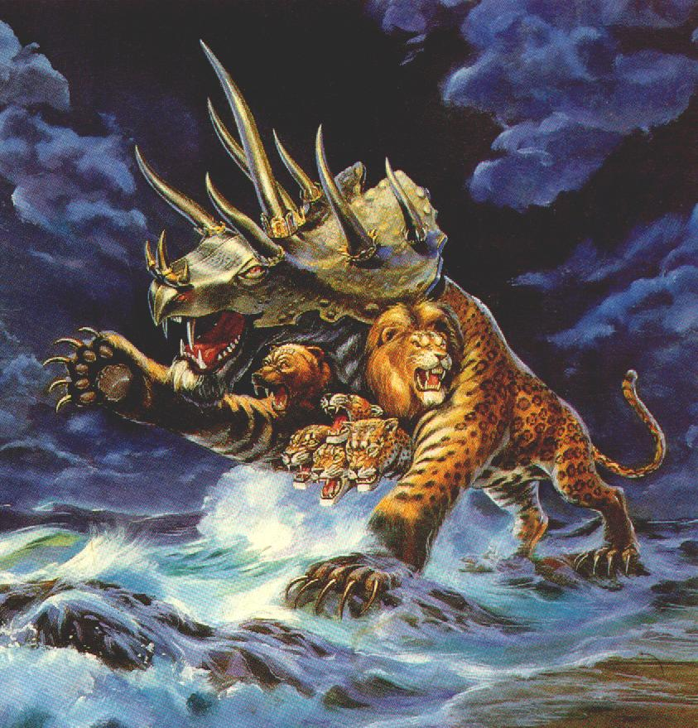
Seven Heads: A conglomerate of the four beasts in Dan 7. v.1-7
Lion head of the Babylonian Kingdom
Bear head of the Medo-Persian Kingdom
Leopard heads (four) of the Greek Kingdom
"Terrible beast" head of the Roman Kingdom
This beast had the strongest parts of the kingdoms it had conquered: body of a leopard, paws of a bear, and mouth of a lion.

Revelation 13: This beast represents the Holy Roman Empire. The Roman Empire conquered the three kingdoms before it: Babylon, Medo-Persia, and Greece. It absorbed these kingdoms and had some of their characteristics.
This beast represented the state arm of the Roman Empire which was a union of church and state, hence the name "Holy." The last 7 revivals of the empire occurred after the state church had come to power. It controlled the following revivals. The state arm was controlled for 42 months (1260 years) from 554-1814 AD. From Justinian's "Imperial Restoration," in 554 to 1814 when the church/state union was dissolved, and no longer politically ruled Europe. The Roman Church was patterned after the Roman Empire's political system (The Pope was patterned after the Roman emperor).
This beast was given the ability to make war with God's saints. This Roman church/state union persecuted God's saints during the Middle ages. During this time period some of God's saints were protected (Rev 12).

