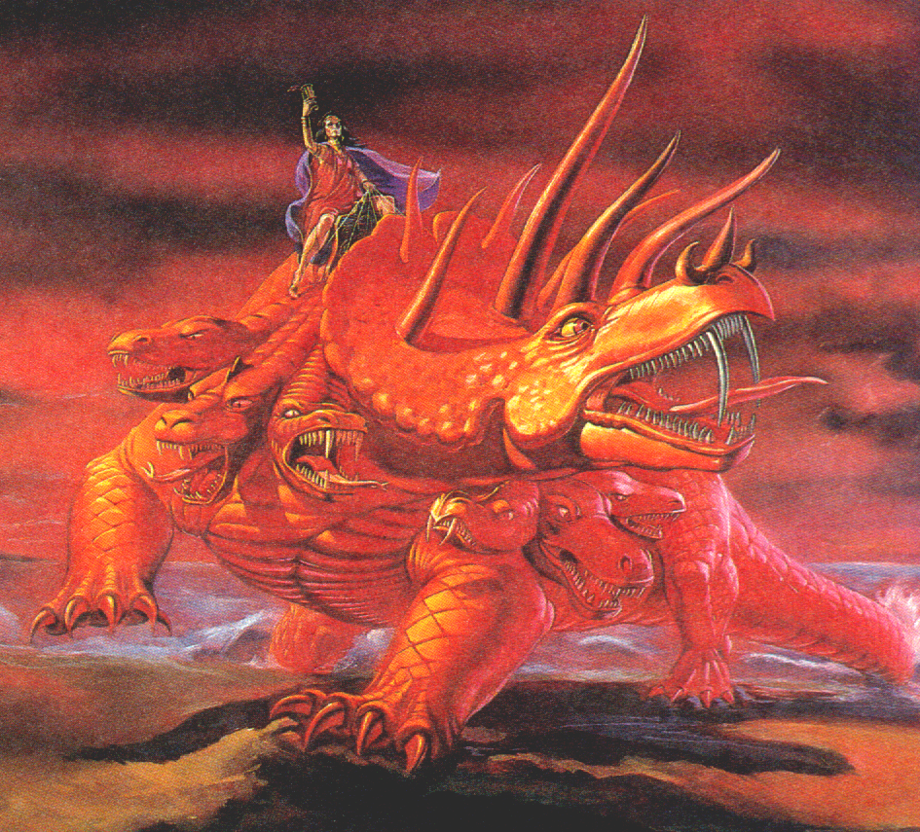
The Scarlet Colored Beast of Rev 17: Representing Spiritual Babylon
The Great Harlot: A Great False religion
This woman rides the last seven revivals of the Roman Empire. She is the same as the little horn. She is drunk with the blood of the saints. Down through history this church has persecuted God's people. She has daughters. Her religion is based on Babylonian Mystery Religion.

The Waters: Humanity
This represents the world; people, multitudes, nations, and tongues v15.
The Seven Heads: The Seven Revivals Controlled by Babylon. These seven revivals are controlled by the Great False Church. The first three of the ten horns, Dan 7 and Rev 13, were uprooted by the little horn, this leaves seven revivals that are controlled by the false church.

The Ten Horns: Final Union of States (US of Europe) These are ten kings that arise out of the final revival. They have power one hour with the beast v12. They make war against the returning Christ and are destroyed by him v. 14.
Seven Heads: Seven Revivals
v. 1-2, (Same as the last seven of the ten jjjjjhorns of Rev 13)
1. Imperial Restoration 554
2. Frankish Kingdom 774
3. Holy Roman Empire Otto the Great (German Head) 962
4. Hapsburg Dynasty (Austrian
Head) 1530
5. Napoleon 1804
6. Italy (Mussolini and
Garibaldi) 1870-1945
7. US of Europe

Revelation 17: The great false church is represented by a whore. This fallen woman rides the resurrected Roman Empire. She is drunk with the blood of the saints. She uses her political manipulation of the beast to make war against the saints. The seven heads are also called seven mountains v.9. The beast is also called a "great city," v. 18. The city of Rome was built on seven hills. The "beast that was, and is not, and yet is," the world will marvel at it's future resurrection v.8. This beast will be destroyed by the returning Christ v.14.

